Unit 8 Review: Rational Expressions
Name: ______________________ TEKS: 2A.7F, 2A.6L, 2A.6I

Part 0: Identifying the LCD
Instruction: Identify the Least Common Denominator (LCD) needed to combine the terms. Do not simplify the entire expression.
- 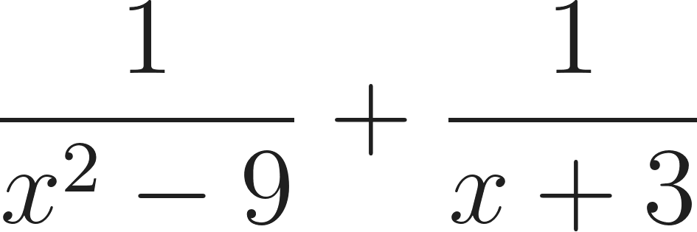 2. 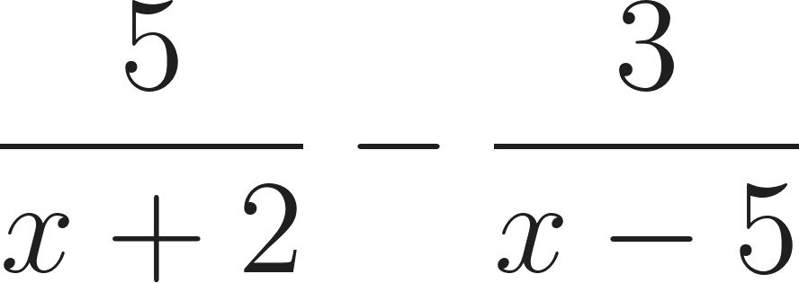

3. 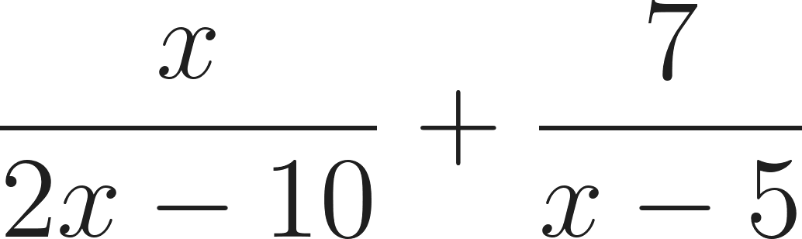 4. 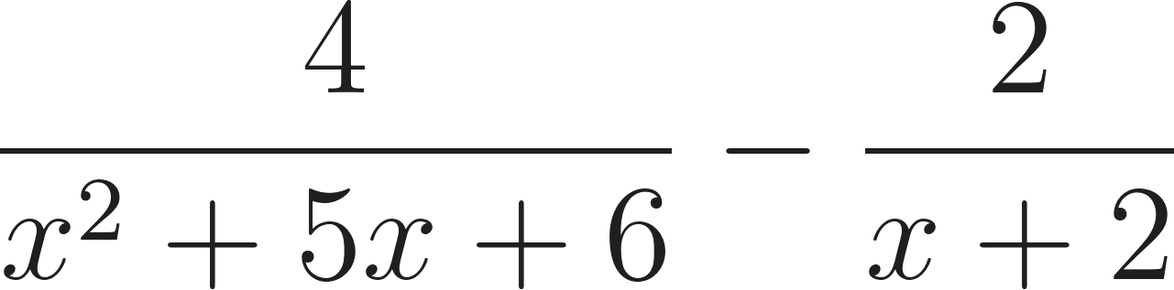

5. 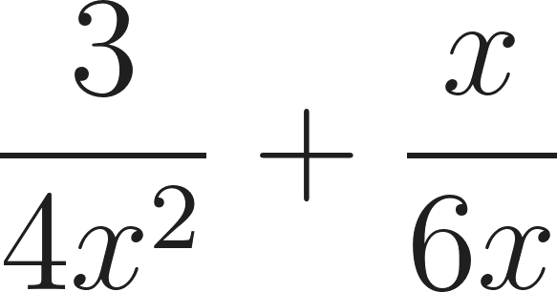

Part 1: Addition
Instruction: Factor denominators, find the LCD, and combine the numerators. List the Excluded values. Simplify the result.
- 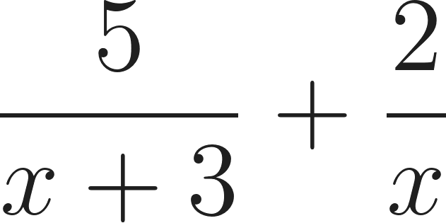 7. 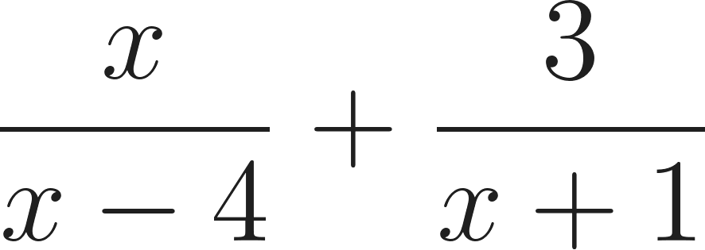

8. 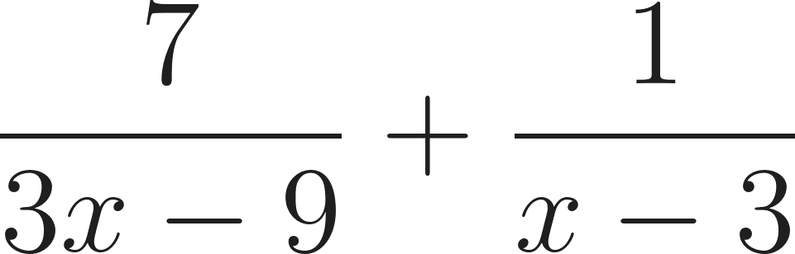 9. 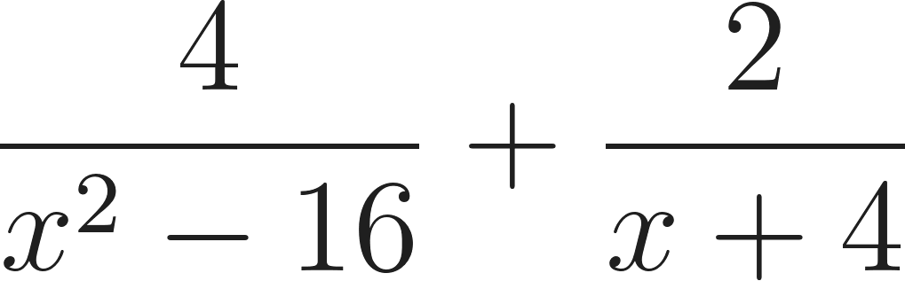

10. 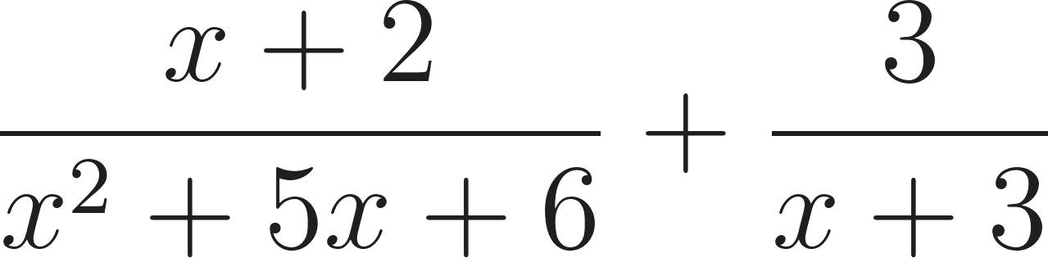

Part 2: Subtraction
Instruction: Find a common denominator and distribute the negative sign to the entire second numerator. List the Excluded values. Simplify the result.
- 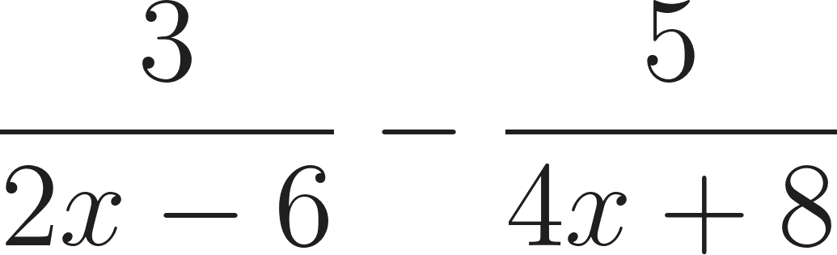 12. 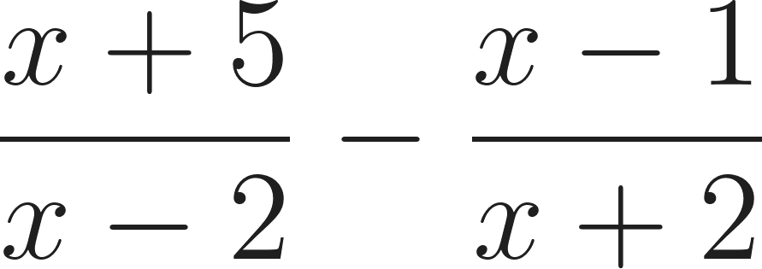

13. 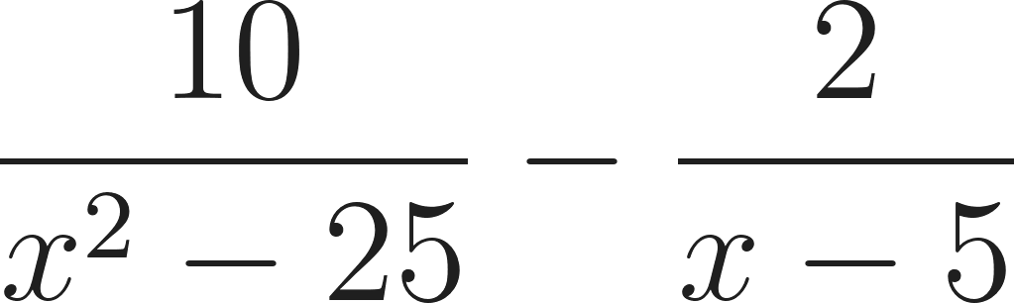 14. 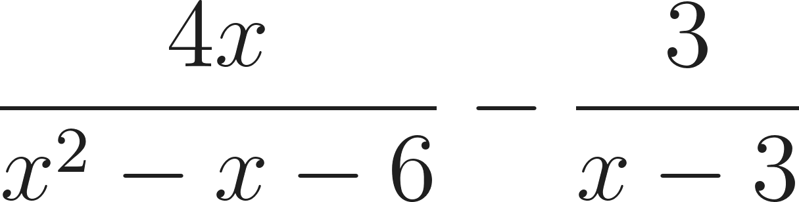

15. 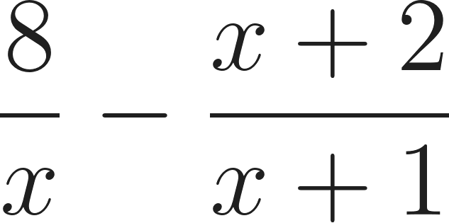

Part 3: Multiplication
Instruction: Factor all parts. Cancel common factors that appear in both the top and the bottom before multiplying across. List the Excluded values. Simplify the result.
- 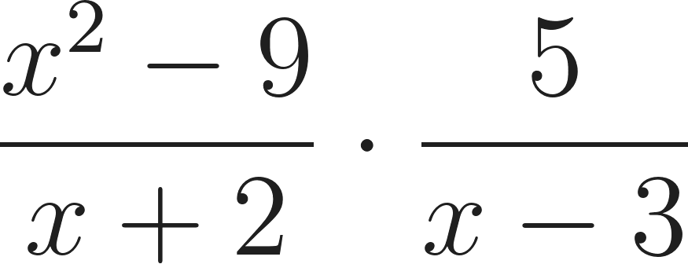 17. 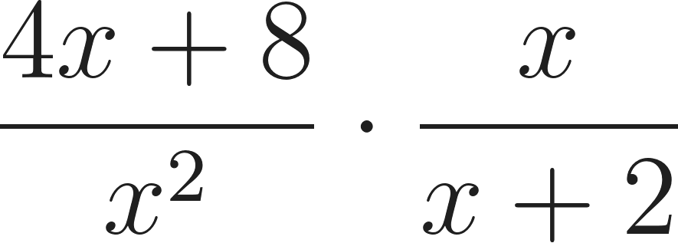

18. 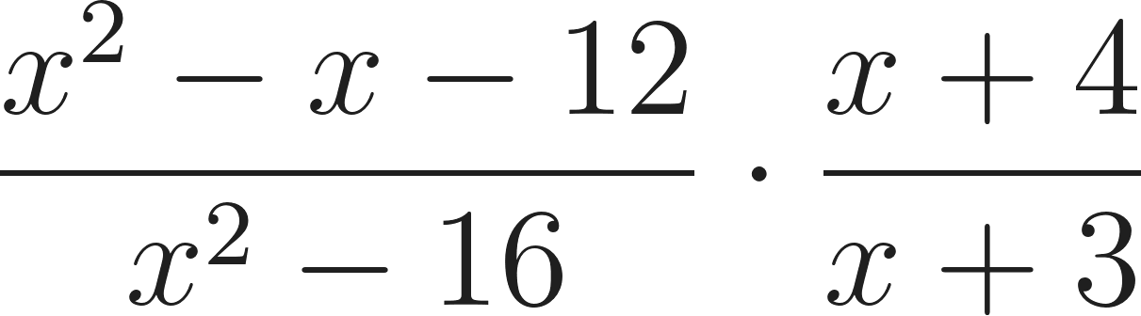 19. 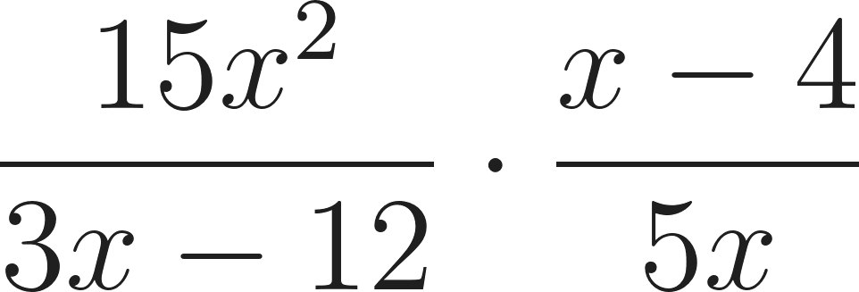

20. 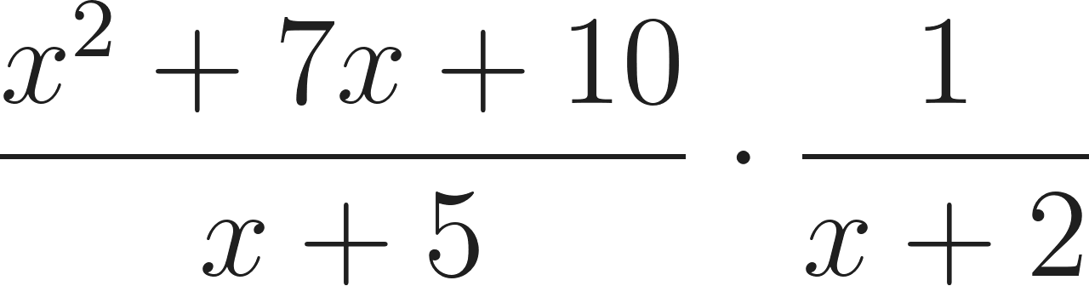

Part 4: Division
Instruction: Apply the "Keep, Change, Flip" rule: keep the first fraction, change to multiplication, and flip the second. List the Excluded values. Simplify the result.
- 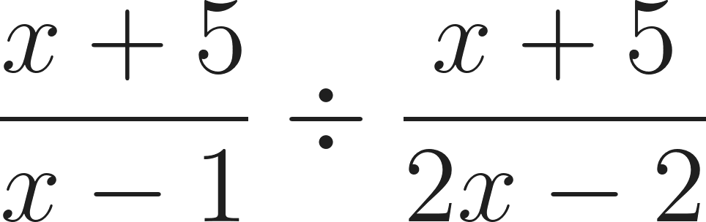 22. 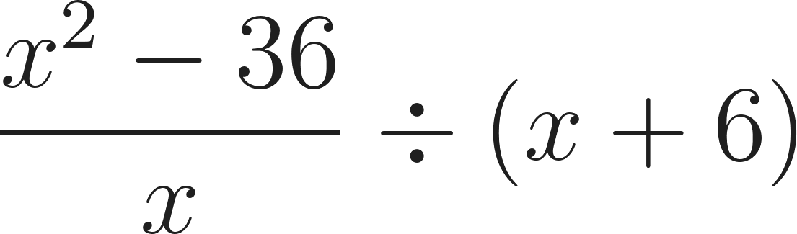

23. 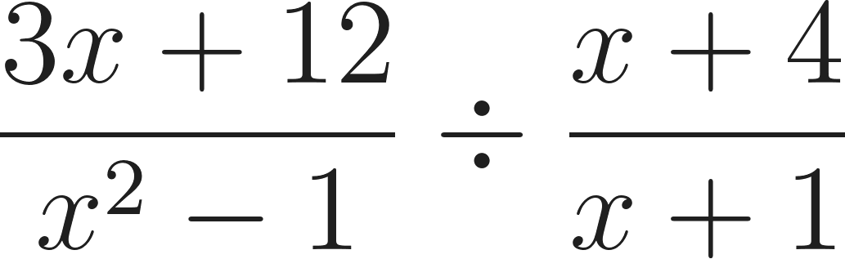 24. 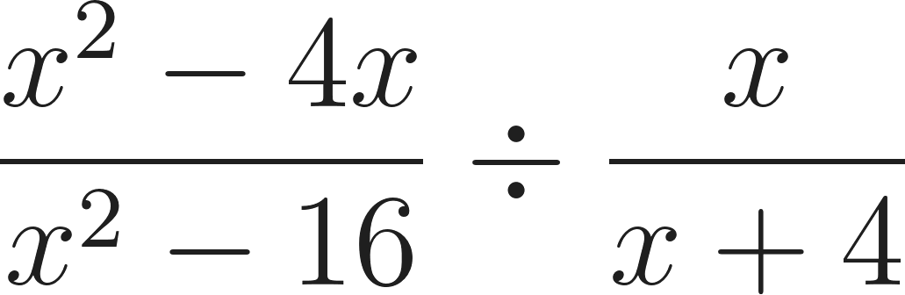

25. 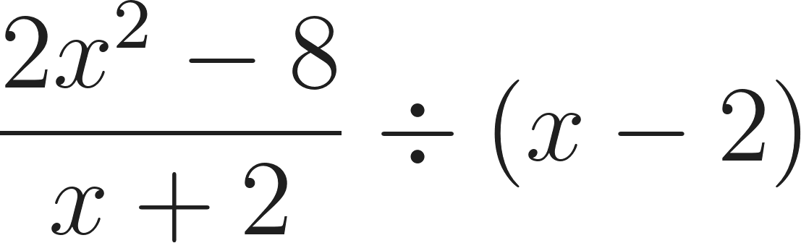

Answer Key
Part 0 (LCDs):
1.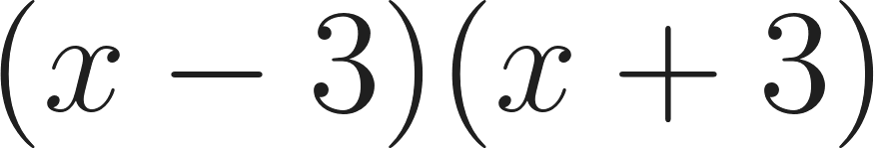 2.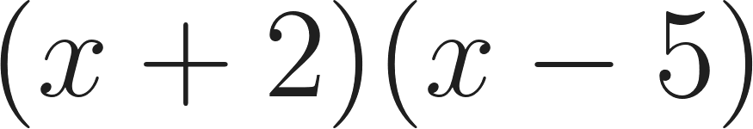 3.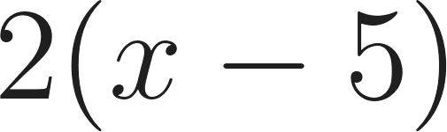 4.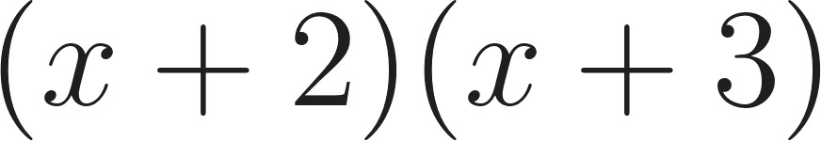 5.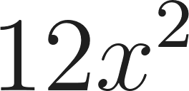
Part 1 & 2: 6. 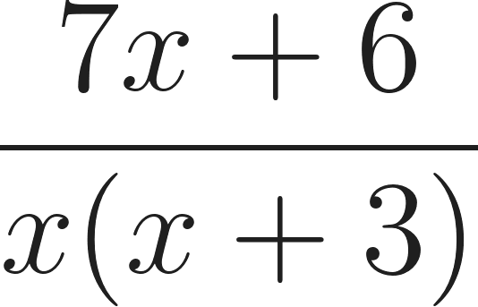 7. 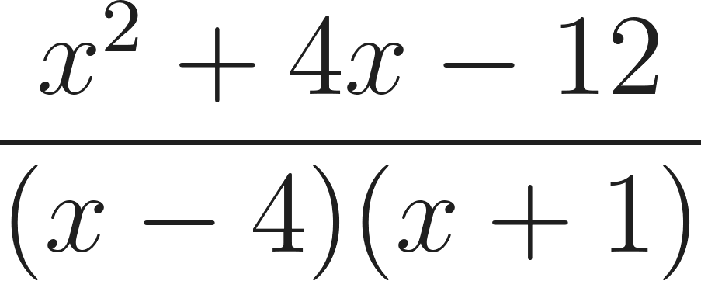 8. 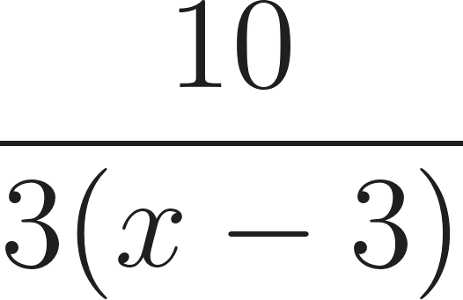 9. 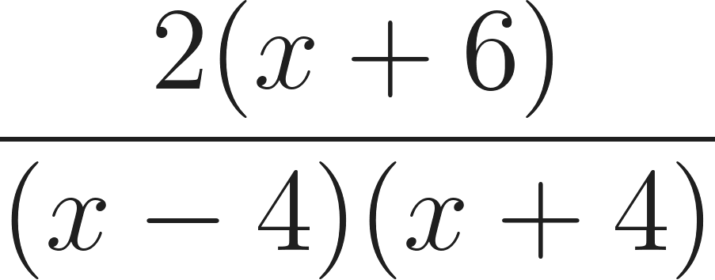 10. 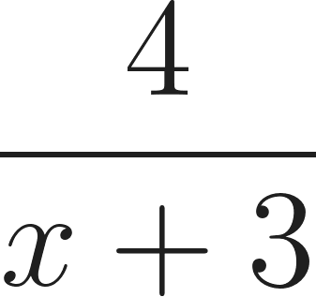
11. 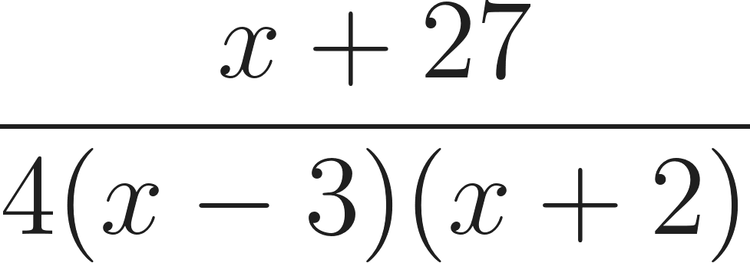 12. 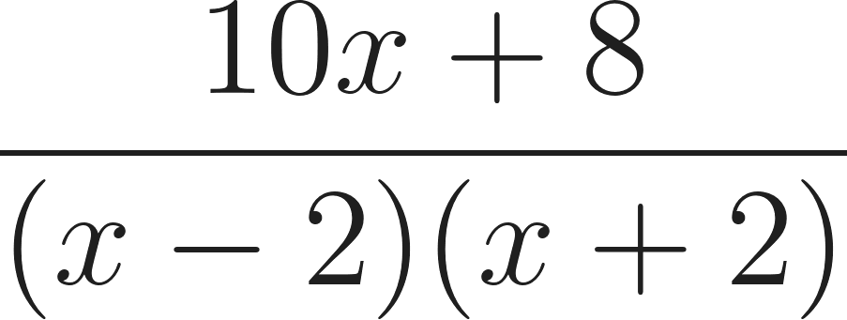13. 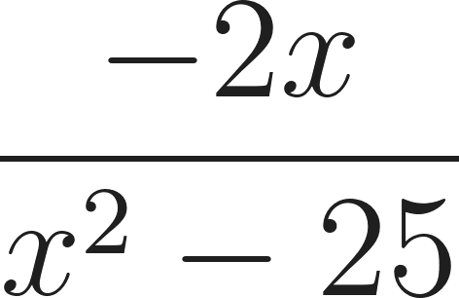 14. 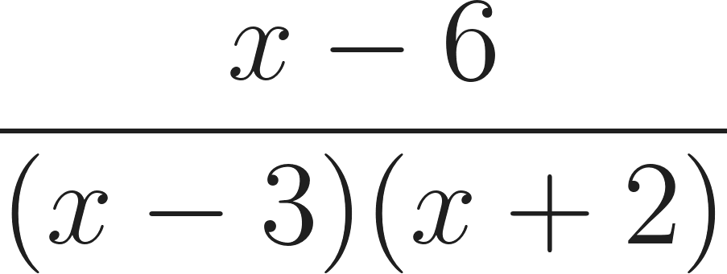 15. 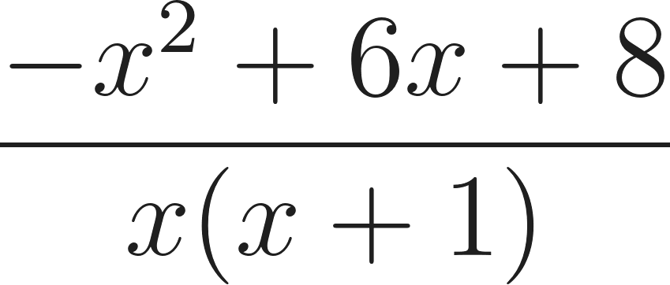
Part 3 & 4: 16. 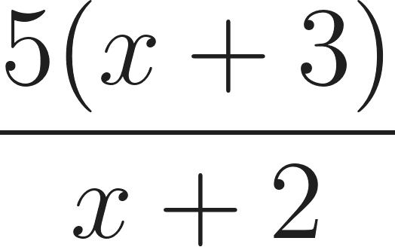 17.  18.  19.  20.  21.  22. 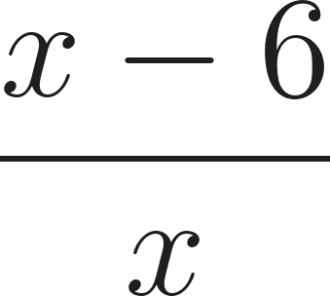 23. 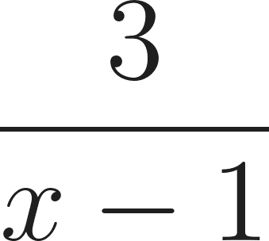 24.  25. 

